

**Semester One Examination 2017**

**Question/Answer Booklet**

**PHYSICS**

**Marking Suggestion**

* Incorrect units on final numerical answer = -1/2 mark
* More than 3 significant figures on final numerical answer = -1/2 mark

**UNIT 1**

**Name: SOLUTIONS**

**Time allowed for this paper**:

Reading time before commencing work: 10 minutes

Working time for paper: 2.5 hours

**Materials required/recommended for this paper**

***To be provides by the supervisor***

This Question/Answer Booklet

Formulae and Data Booklet

***To be provided by the candidate***

Standard items: pens, pencils (including coloured), sharpener, correction fluid, eraser, ruler, highlighters.

Special items: up to three non-programmable calculators approved for use in the WACE examinations, drawing templates, drawing compass and a protractor.

**STRUCTURE OF THIS PAPER**

|  |  |  |  |  |  |  |
| --- | --- | --- | --- | --- | --- | --- |
| Section | No. of  Questions | No. of questions  to be attempted | Suggested working time  (minutes) | | Marks available | Percentage of  exam |
| 1: Short Response | 13 | ALL | 48 | | 48 | 32% |
| 2: Problem Solving | 6 | ALL | 76 | | 76 | 51% |
| 3: Comprehension | 2 | ALL | 26 | | 26 | 17% |
| Total | **150** | **100** |

**INSTRUCTIONS TO CANDIDATES**

Write your answers in the spaces provided beneath each question. The value of each question (out of 180) is shown following each question.

The enclosed Physics: Formulae and Constants Sheet may be removed from the booklet and used as required.

Calculators satisfying conditions set by the School Curriculum and Standards Authority may be used to evaluate numerical answers. The calculator **cannot** be a “**graphics”** calculator.

Answers to questions involving calculations should be evaluated and given in decimal form. Final answers should be given up to three significant figures and include appropriate units where appropriate. Despite an incorrect final result, credit may be obtained for method and working providing these are clearly and legibly set out.

Questions containing specific instructions to **show working** should be answered with a complete, logical, clear sequence of reasoning showing how the final answer was arrived at; correct answers which do not show working will not be awarded full marks.

Questions containing the instruction "**ESTIMATE**" may give insufficient numerical data for their solution. Show your working or reasoning clearly. Give final answers to a maximum of two significant figures and include appropriate units where applicable.

**Section One: Short Response 32% (48 marks)**

This section has 13 questions. Answer **all** questions. Answer the questions in the spaces provided.

Suggested working time: 50 minutes.

**Question 1 (4 marks)**

1. Draw a **labelled** diagram of a Helium atom, ${}_{2}^{4}{He}$ (not to scale). (2 marks)

* Clearly shows 2 protons and 2 neutrons in the nucleus (labelled) (1)
* Clearly shows two electrons orbiting/outside the nucleus (labelled) (1)

*[0 marks if not labelled]*

Electron

Neutron

Proton

1. In the nucleus of an atom many positively charged protons are packed closely together. Explain why the protons in the nucleus don’t fly apart due to electrostatic repulsion. (2 marks)

* The strong nuclear force acts between the protons and neutrons (1)
* Strong nuclear force only acts over very short distances
* So when protons are close together (like in a nucleus) the strong nuclear force is stronger than the electrostatic repulsion between the protons (1)

**Question 2 (3 marks)**

Dogs don’t sweat like humans do, after exercising they pant to cool down. When dogs pant they stick out their wet tongue and blow air over it. Explain how the action of panting helps the dog cool down.

* Air passing over the tongue helps more saliva/water evaporate (1)
* Saliva/water requires heat (latent heat of vaporisation) to evaporate (turn from liquid to gas) (1)
* Saliva/water takes that large amount of heat from the dog’s tongue (1)
* By removing heat from dog panting helps keep the dog cool

**Question 3 (6 marks)**

Two incandescent light bulbs are connected in parallel to a household 240.0 V power source. One light bulb is rated as 60.0 W and the second light bulb is rated as 80.0 W.

1. Calculate which light bulb draws the most current. (2 mark)

$$I=\frac{P}{V}$$

$$I_{1}=\frac{60}{240}$$

$I_{1}=0.25 A$ (1)

$$I_{2}=\frac{80}{240}$$

$I_{2}=0.33 A$ (1)

The 80.0 W light bulb draws the most current.

1. The light bulbs are then placed in a series circuit. Calculate the current through each light bulb.

(4 marks)

$$R_{1}=\frac{V}{I_{1}}$$

$$R_{1}=\frac{240}{0.25}$$

$R_{1}=960 Ω$ (1)

$$R_{2}=\frac{240}{0.33}$$

$R_{2}=727 Ω$ (1)

$$R_{T}=R_{1}+R_{2}$$

$R_{T}=960+727=1687 Ω$ (1)

$$I=\frac{V}{R}$$

$$I=\frac{240}{1687}$$

$I=0.142 A$ (1)

Both will have the same current, 0.142 A.

**Question 4 (3 marks)**

A doctor of mass 75.0 kg is taking images of a patient using a beta radiation source. If the radioisotope delivers 8.10 × 10-2 J of energy, calculate the equivalent dose the doctor receives.

$Absorbed dose=E/m$

$Absorbed dose=\frac{8.10×{10}^{-2}}{75}$ (1)

$Absorbed dose=1.08×{10}^{-3} Gy$ (1)

$Dose equivalent=absorbed dose ×quality factor$

$Dose equivalent=1.08×{10}^{-3}×1$

$Dose equivalent=1.08×{10}^{-3} Sv$ (1)

**Question 5 (4 marks)**

A 3.85 V battery is used to power a smart phone. The smart phone draws a current of 21.1 mA when watching videos. Calculate how much electrical potential energy is consumed while watching a 5.00 minute video clip.

$$q=It$$

$q=21.1×{10}^{-3}×300$ (1)

$q=6.33 C$ (1)

$$W=Vq$$

$W=3.85×6.33$ (1)

$W=24.4 J$ (1)

**Question 6 (4 marks)**

Computers get very hot after being used for a long time, so they often contain fans which move air through the computer case. The fan draws air in through the front of the computer case and blows it out through the back.

1. Describe how moving air through the case keeps the computer electronics cool. (2 marks)

* The computer transfers heat energy to the air around it through conduction (1)

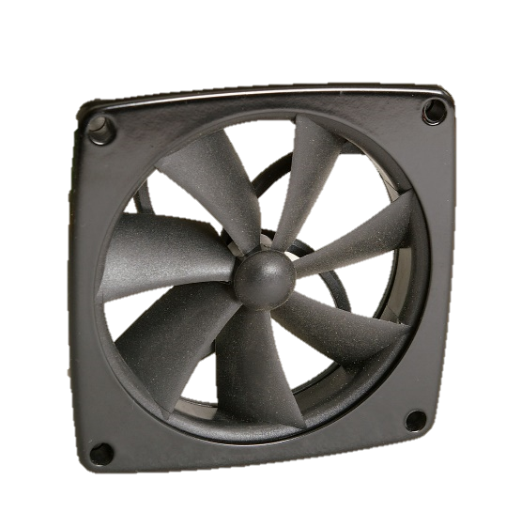

* As the air keeps being replaced the computer can’t reach thermal equilibrium with the air (1)
* So, they computer keeps losing heat energy, thus remaining cool

1. Some computers are water-cooled. They pump cold water through pipes positioned alongside components to keep the computer cool. Which system (air cooling or water cooling) would be the most effective at keeping the computer cool? Explain the reasoning behind your answer. (2 marks)

* Water cooling (1)
* Water has a high specific heat capacity, can absorb a lot of heat energy from the computer before increasing in temperature (more than air) (1)

**Question 7 (4 marks)**

Complete the following nuclear decay equations:

1. ${}_{94}^{240}{Pu}→ {}_{94}^{240}{Pu}+{}_{0}^{0}γ$ (1 mark)
2. ${}_{11}^{24}{Na}→{}_{12}^{24}{Mg}+{}_{-1}^{0}e$ (OR ${}_{-1}^{0}β$) (1 mark)
3. ${}_{89}^{221}{Ac}→{}_{87}^{217}{Fr}+{}_{2}^{4}{He}$ (OR ${}_{2}^{4}α$) (1 mark)
4. ${}_{84}^{210}{Po}→{}_{2}^{4}{He}+{}_{82}^{206}{Pb}$ (1 mark)

**Question 8 (3 marks)**

The cups shown below are used to hold hot drinks, such as tea or coffee.

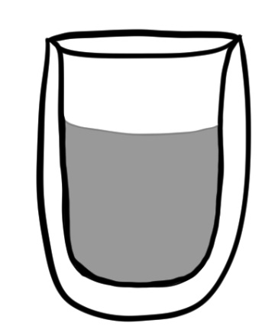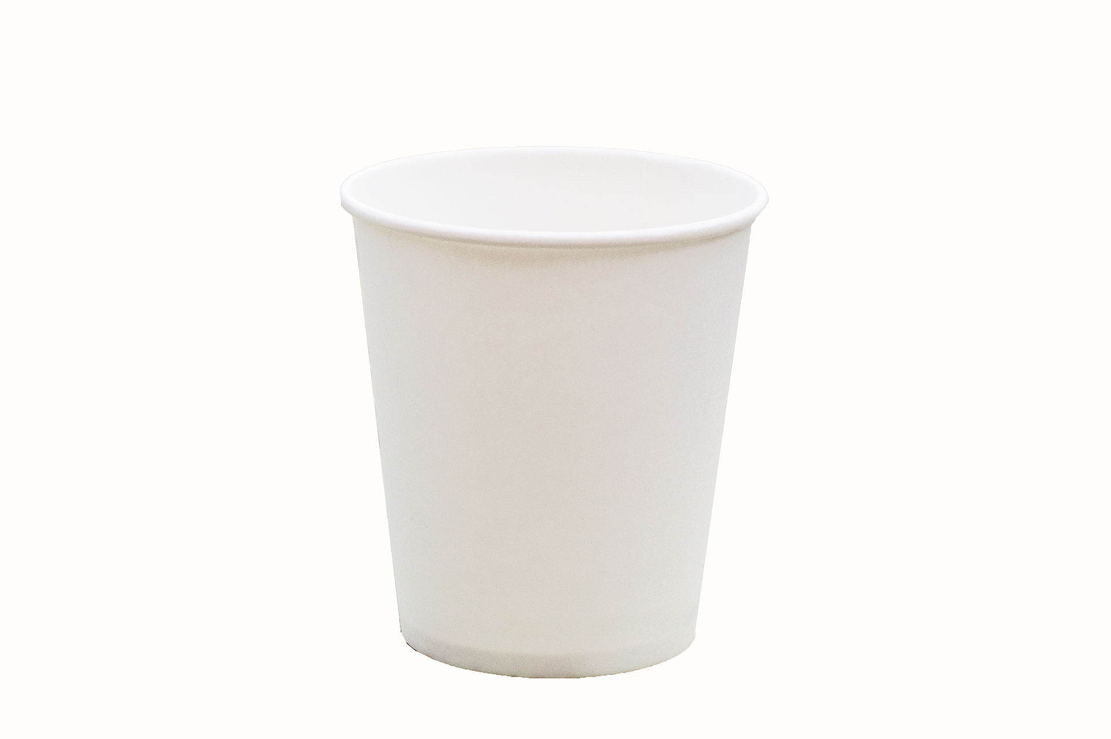

Glass

Layer of air

*Paper cup*

*Glass double-wall cup*

1. Which cup is better at preventing your hand from getting burnt? (1 mark)

* The glass, double-wall cup (1)

1. Explain why your chosen cup from part a) is more effective at preventing burns. (2 marks)

* The double-wall cup has a big air gap, air is a good insulator (1)
* Insulators don’t conduct heat very well (1)
* Less heat conducted to outside of cup and to your hand

**Question 9 (3 marks)**

Draw a **labelled** circuit diagram of a parallel circuit containing a battery, two light bulbs and a switch. Arrange the components so that when the switch is closed both lights are on, but when the switch is open only one light is on.

* All components included and drawn with correct symbols (1)
* Components are labelled correctly (1)
* Circuit drawn as below (so when switch is closed both lights are on) (1)

Battery

Light bulb

Switch

**Question 10 (4 marks)**

An electric kettle with a rating of 300.0 W takes 2.50 mins to heat water from 25.0 °C to 70.0 °C. Calculate how much water was in the kettle. (Assume the transfer of energy is 100% efficient).

$$W=P×t$$

$W=300 W×150 s$ (1)

$W=4.5×{10}^{4}J$ (1)

$$W=Q$$

$m=\frac{Q}{c∆T}$ (1)

$$m=\frac{4.5×{10}^{4}}{4.18×{10}^{3}×(70-25)}$$

$m=2.39×{10}^{-1}kg$ (1)

**Question 11 (3 marks)**

1. Name one safety feature used in modern households to prevent electrical shocks (1 mark)

Any ONE of the following: (1)

* Residual Current Device (RCD)
* Earth wire
* Fuse
* Double insulation

*[Can also accept other appropriate answers]*

1. Describe how the safety feature you named in part a) works (2 marks)

* Residual Current Device (RCD)
  + In a circuit the Active and Neutral wires should have the same current flowing through them
  + An RCD detects any difference in current between Active and Neutral wires and switches off the circuit
* Earth wire
  + If a part of an appliance breaks and the metal casing becomes active
  + The earth wire provides a path for the electricity to get to the ground
  + Lower resistance than going through a human body, protects from electrocution
* Fuse
  + When a short circuit occurs (or dangerously high current passes through circuit)
  + A fuse is a thin conductor, when large current passes through the fuse it will heat up and melt
  + When fuse breaks there is no longer a complete circuit and current no longer flows
* Double insulation
  + Insulators don’t conduct electricity, if touch insulator you won’t be electrocuted
  + Double layer of insulation ensures that even if one layer fails the second layer is still intact.

**Question 12 (3 marks)**

There are $9.00×{10}^{18}$ atoms in a sample of a radioactive element. If the element has a half-life of 10.0 minutes, calculate how many atoms of this element remain after 1.00 hour.

$$N=N_{0}{\left(\frac{1}{2}\right)}^{n}$$

${60 mins}/{10 mins}=6 half lives$ (1)

$N=9.00×{10}^{18}{\left(\frac{1}{2}\right)}^{6}$ (1)

$N=1.41×{10}^{17} atoms$ (1)

**Question 13 (4 marks)**

A football coach has a large container holding 50 L of sports drink for his team. The sports drink starts at 35 °C and needs to be cooled down to 0 °C before half time.

Calculate how much ice (initially at -10 °C) the coach needs to add to the sports drink in order to cool it down to 0 °C. (Assume sports drink has the same properties as water and that all the ice melts).

$$-Q_{lost (sports drink)}=Q_{gained (ice)}$$

$-{mc∆T}_{sports drink}={mc∆T}_{ice}+mL_{f}$ (1)

$- 50×4.18×{10}^{3}×\left(0-35\right)=m×2.1×{10}^{3}×\left(0--10\right)+m×3.34×{10}^{5}$ (1)

$$7.315×{10}^{6}=3.55×{10}^{5}m$$

$m=20.6 kg$ (2)

**END OF SECTION ONE**

**Section Two: Problem-solving 53% (94 marks)**

This section contains 7 questions. Answer **all** questions. Answer the questions in the spaces provided.

Suggested working time 90 minutes.

**Question 14 (13 marks)**

Sous vide is a way of cooking food at a low temperature over a long period of time. A sous vide machine is made of a container of water with a submerged heating element (see diagram below). An electrical current passes through the heating element, warming it up which then warms the water to a constant temperature. Food (e.g. steak) is placed in sealed bags and cooks in the warm water.

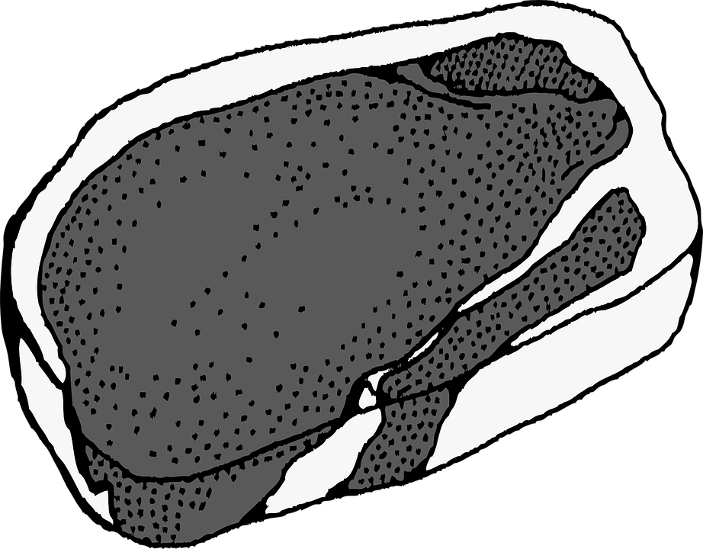

Water

Vacuum sealed bag

Steak

Heating element

Figure 1: Sous vide machine

1. A chef places 6.20 L of 28.0 °C water into a sous vide machine. The machine is rated at 2.10 kW. Calculate how long it takes the sous vide machine to heat the water up to 56.5 °C. (4 marks)

$$Q=mc∆T$$

$Q=6.20×4180×(56.5-28.0)$ (1)

$Q=7.39×{10}^{5} J$ (1)

$$Q=W$$

$t=W/P$

$t=7.39×{10}^{5}/2.1×{10}^{3}$ (1)

$t=352 s$ (1)

1. It actually took the sous vide machine 8.30 minutes to heat up the water from part a). Calculate the efficiency of the sous vide machine. (3 marks)

**Alternatively:**

$η=\frac{time taken \left(part a\right) ) }{time taken acutal}×100$ (1)

$η=\frac{352 }{498}×100$ (1)

$η=70.7\%$ (1)

$$W_{input}=Pt$$

$W_{input}=2.1×{10}^{3}×(8.3×60)$ (1)

$W_{input}=1.05×{10}^{6} J$ (1)

$Q=W_{output}=7.39×{10}^{5} J$

$$η=\frac{energy output}{energy input}×100$$

$η=\frac{7.39×{10}^{5} }{1.05×{10}^{6}}×100$ (1)

$η=70.4 \%$

1. Some chefs are arguing over whether sous vide or pan frying is a better technique for cooking a steak. One chef argues that “in a sous vide machine the food cannot be over cooked.” Explain how this could be possible. (2 marks)

* In sous vide machine temperature of water is set
* Steak reach thermal equilibrium with water, can never be higher temp than water

1. A 300 g steak and 250 g of carrots were taken out of the fridge at 5.00 °C. The food was added to the sous vide machine when the water was 56.5 °C. However, the sous vide machine was accidentally turned off as soon as the food was added (so no extra heat was added to the water). Calculate the final temperature of the steak and carrots. Assume no energy is lost. (4 marks)

|  |  |
| --- | --- |
| **Food** | **Specific Heat Capacity (J K-1 kg-1)** |
| Steak |  |
| Carrot | $$3.81×{10}^{3}$$ |

$$-Q_{lost}=Q_{gained}$$

$-6.20×4180×(T_{f}-56.5)=0.3×2760×(T_{f}-5)+0.25×3810×(T_{f}-5)$ (2)

$$-2.59×{10}^{4} T_{f} +1.46×{10}^{6} =1.78×{10}^{3}T_{f}-8.90×{10}^{3}$$

$1.47×{10}^{6} =2.77×{10}^{4}T_{f}$ (1)

$$T_{f}=1.47×{10}^{6}/ 2.77×{10}^{4}$$

$T_{f}=53.1 ℃$ (1)

**Question 15 (11 marks)**

A student conducts an experiment using an electric heater with a power rating of 3.00 kW to heat 2.50 x 102 g of ice, initially at 0.00 °C. The ice melts and after a while the resulting water begins to boil. Assume the heater transfers heat to the ice/water with 100% efficiency.

1. Calculate how much energy is required to completely melt the ice. (2 marks)

$$Q=mL_{f}$$

$Q=0.25×3.34×{10}^{5}$ (1)

$Q=8.35×{10}^{4} J$ (1)

1. Calculate how long it takes to melt the ice. (2 marks)

$$t=\frac{Q}{P}$$

$t=\frac{8.35×{10}^{4}}{3×{10}^{3}}$ (1)

$t=27.8 s$ (1)

1. The heater continues to heat the melted ice until the water begins to boil. Calculate how much energy the water needs to reach 100 °C. (2 marks)

$$Q=mc∆T$$

$Q=0.25×4180×100$ (1)

$Q=1.05×{10}^{5} J$ (1)

1. Calculate how long it takes for the melted ice to reach 100 °C. (2 marks)

$$t=\frac{Q}{P}$$

$t=\frac{1.05×{10}^{5}}{3×{10}^{3}}$ (1)

$t=35.0 s$ (1)

1. On the graph below plot what happens to the temperature (y-axis) over time (x-axis) as the ice melts and then the water begins to boil. Use data from part a) to d). (3 marks)

Temperature (°C)

|  |  |  |  |  |  |  |  |  |  |  |  |  |  |  |  |  |  |
| --- | --- | --- | --- | --- | --- | --- | --- | --- | --- | --- | --- | --- | --- | --- | --- | --- | --- |
|  |  |  |  |  |  |  |  |  |  |  |  |  |  |  |  |  |  |
|  |  |  |  |  |  |  |  |  |  |  |  |  |  |  |  |  |  |
|  |  |  |  |  |  |  |  | (1) Scales on axes are correct  (2) Data points graphed accurately  (0,0), (27.8, 0), (62.8, 100) |  |  |  |  |  |  |  |  |  |
|  |  |  |  |  |  |  |  |  |  |  |  |  |  |  |  |  |  |
| 125 |  |  |  |  |  |  |  |  |  |  |  |  |  |  |  |  |  |
|  |  |  |  |  |  |  |  |  |  |  |  |  |  |  |  |  |  |
| 100 |  |  |  |  |  |  |  |  |  |  |  |  |  |  |  |  |  |
|  |  |  |  |  |  |  |  |  |  |  |  |  |  |  |  |  |  |
| 75 |  |  |  |  |  |  |  |  |  |  |  |  |  |  |  |  |  |
| 50 |  |  |  |  |  |  |  |  |  |  |  |  |  |  |  |  |  |
|  |  |  |  |  |  |  |  |  |  |  |  |  |  |  |  |  |  |
|  |  |  |  |  |  |  |  |  |  |  |  |  |  |  |  |  |  |
| 25 |  |  |  |  |  |  |  |  |  |  |  |  |  |  |  |  |  |
|  | 0 |  |  |  |  |  |  |  |  |  |  |  |  |  |  |  |  |
|  |  |  |  | 20 |  |  |  |  | 40 |  |  |  | 60 |  |  | 80 |  |
|  |  |  |  |  |  |  |  |  |  |  |  |  |  |  |  |  |  |
|  |  |  |  |  |  |  |  |  | Time (s) |  |  |  |  |  |  |  |  |

**Question 16 (12 marks)**

Two physics students conducted an experiment to measure the resistance of a resistor. Their results are shown in the table below.

*Table 1: Student’s results table*

|  |  |
| --- | --- |
| **Voltage (V)** | **Current (mA)** |
| 4 | 29 |
| 6 | 44 |
| 8 | 58 |
| 11 | 82 |
| 12 | 88 |

1. Graph the students’ results on the grid below. (3 marks)

Voltage (V)

|  |  |  |  |  |  |  |  |  |  |  |  |  |  |  |  |  |  |
| --- | --- | --- | --- | --- | --- | --- | --- | --- | --- | --- | --- | --- | --- | --- | --- | --- | --- |
|  |  |  |  |  |  |  |  |  |  | Voltage vs Current |  |  |  |  |  |  |  |
|  |  |  |  |  |  |  |  |  |  |  |  |  |  |  |  |  |  |
|  |  |  |  |  |  |  |  | (1) Scales on axes are correct  Labels and units on axes are correct  (1) Data points graphed accurately  (1) Graph has an appropriate title  (Swapped axes are ok) |  |  |  |  |  |  |  |  |  |
|  |  |  |  |  |  |  |  |  |  |  |  |  |  |  |  |  |  |
| 12 |  |  |  |  |  |  |  |  |  |  |  |  |  |  |  |  |  |
|  |  |  |  |  |  |  |  |  |  |  |  |  |  |  |  |  |  |
| 10 |  |  |  |  |  |  |  |  |  |  |  |  |  |  |  |  |  |
|  |  |  |  |  |  |  |  |  |  |  |  |  |  |  |  |  |  |
| 8 |  |  |  |  |  |  |  |  |  |  |  |  |  |  |  |  |  |
| 6 |  |  |  |  |  |  |  |  |  |  |  |  |  |  |  |  |  |
|  |  |  |  |  |  |  |  |  |  |  |  |  |  |  |  |  |  |
|  |  |  |  |  |  |  |  |  |  |  |  |  |  |  |  |  |  |
| 4 |  |  |  |  |  |  |  |  |  |  |  |  |  |  |  |  |  |
|  | 2 |  |  |  |  |  |  |  |  |  |  |  |  |  |  |  |  |
|  |  |  |  |  |  |  |  |  |  |  |  |  |  |  |  |  |  |
|  |  |  |  |  |  |  |  |  |  |  |  |  |  |  |  |  |  |
|  |  |  |  | 0.02 |  |  | 0.04 |  |  | 0.06 |  |  | 0.08 |  |  | 0.1 |  |

Current (A)

1. Draw a line of best fit on the graph above. (1 mark)

Line must be as close as possible to all data points, must be straight (linear), should not be a ‘join the dots’.

1. Using the data given above and your graph, calculate the experimental value for the resistance for the resistor. (3 marks)

$m=\frac{rise}{run}$ $R=\frac{V}{I}$

$$m=\frac{(11-4)}{(0.08-0.026)}$$

$$m=\frac{7}{0.054}$$

$$m=R=129.6 Ω$$

Full marks if students show appropriate working and get a number around $R=130 Ω$

Watch for units on current, need to be converted to A in order for answer to be in Ω.

1. The students read the colour coding on the resistor, finding the accepted value of the resistor is 130 Ω ± 2%.

Calculate the percentage difference between the experimental value you calculated in part c) and the accepted value. Comment on whether your experimental result is within the accepted range or not.

(3 marks)

$\% difference=\frac{0.4}{130}×100$ (1)

$\% difference=0.3\%$ (1)

Yes, my experimental result is within the accepted range of 2%. (1)

*[Also accept ‘No, not within 2%’ if maths is correct, depending on result from part c)]*

1. Describe one way the students could reduce the uncertainty in their initial measurements. (2 marks)

Any ONE of the following:

* Use more sensitive measuring equipment (2)
* Do multiple trials/measurements (2)
* Wider range of voltages/measurements tested (2)

**Question 17 (14 marks)**

Nuclear reactors use fission reactions to generate electricity. In the nuclear reactor shown in Figure 2 the energy generated by fission heats up the water, the water boils creating steam which turns a turbine creating electricity.

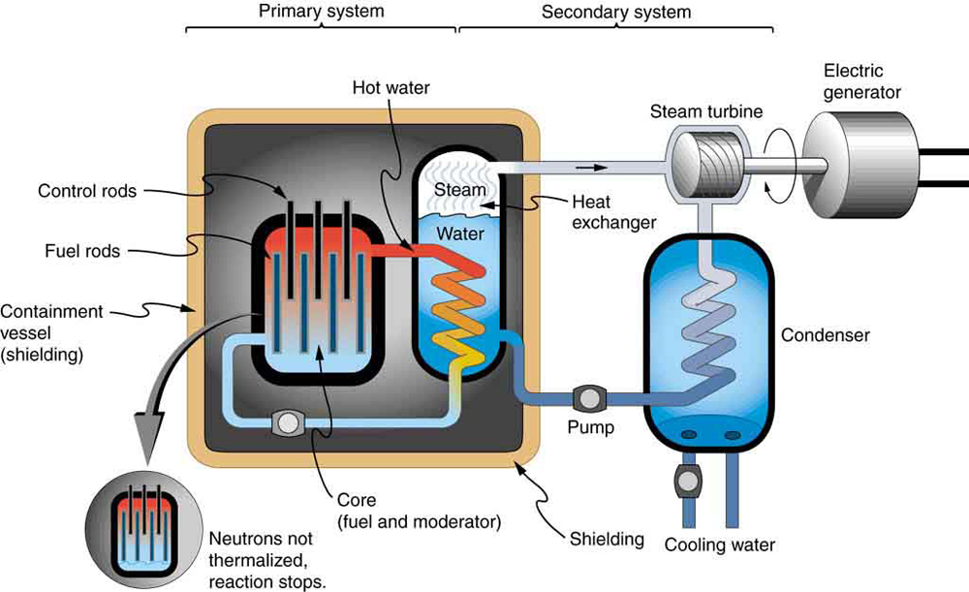

Figure 2: Pressurised water nuclear reactor diagram

The nuclear reactor shown above uses Uranium-238 as a fuel source. The Uranium undergoes fission according to the following equation:

$${}_{0}^{1}n+{}_{92}^{238}U→{}_{38}^{96}{Sr}+{}_{54}^{140}{Xe} + ?{}_{0}^{1}n$$

1. How many neutrons are released as a product of this fission reaction? (1 mark)

$239-\left(96+140\right)=3$ (1)

1. Calculate the energy (in electron volts) released by the fission reaction shown in part a). (3 marks)

|  |  |
| --- | --- |
| **Element** | **Mass (u)** |
| Uranium-238 | 238.050784 |
| Strontium-38 | 95.921750 |
| Xenon-140 | 139.92164 |
| Neutron | 1.008665 |

$$∆m=\left[m\left({}_{0}^{1}n\right)+m\left({}_{92}^{238}U\right)\right]-[m\left({}_{38}^{96}{Sr}\right)+m\left({}_{54}^{140}{Xe}\right)+3×m\left({}_{0}^{1}n\right)]$$

$∆m=\left(1.008665+238.050784\right)-(95.921750+139.92164+3×1.008665)$ (1)

$∆m=0.190064 u$ (1)

$∆E=0.190064×931$ (1)

$∆E=1.77×{10}^{8} eV$

1. Name and describe two safety features used in nuclear reactors. (4 marks)

Any TWO of the following:

[1 mark – naming features, 1 mark – describing how it works]

* Moderator
  + slows neutrons down so they can undergo fission. If it boils away there are less slow neutrons, so less fission reactions
* Control rods
  + absorb extra neutrons so the chain reaction doesn’t go out of control, can also prevent over heating
* Shielding
  + Absorbs radiation and reduces the intensity of the radiation escaping the reactor, the thicker shield the less radiation gets through
* Cooling systems
  + removes excess heat from the reactor, stops the nuclear fuel from reaching its melting point
* Radiation monitors
  + measure how much radiation staff have been exposed to in order to keep their level of exposure below accepted standards

1. Explain why it is easier for a neutron to enter the nucleus compared to an alpha particle or a proton. (2 marks)

* Alpha particle and proton have a positive charge, whereas neutrons have no charge (1)
* The nucleus is positively charged (1)
* Like charges repel

1. The electrical power output of the nuclear reactor facility is 901 MW. Calculate the mass of Uranium-235 fissioned in one year of full-power operation. (4 marks)

$$E=P×t$$

$E=901×{10}^{6}×(60×60×24×365)$ (1)

$E_{year}=2.84×{10}^{16} J$ (1)

$∆E=1.77×{10}^{8} eV= 2.83×{10}^{-11} J$ per atom of ${}_{92}^{235}U$

$\#{}_{92}^{235}U atoms= \frac{2.84×{10}^{16}}{2.83×{10}^{-11}}$ (1)

$$\#{}_{92}^{235}U atoms= 1×{10}^{27} atoms$$

$One {}_{92}^{235}{U atom}=3.95×{10}^{-25} kg$

$m\left({}_{92}^{235}U\right)=1×{10}^{27}×3.95×{10}^{-25}$ (1)

$m\left({}_{92}^{235}U\right)=395 kg$

**Question 18 (14 marks)**

A circuit consisting of a 9.00 V power source and four resistors is shown below. When the switch is open the total current in the circuit is 0.961 A.

9.00 V

3.15 Ω

X

2.00 Ω

R1

R3

R2

R4

4.00 Ω

1. Calculate the resistance value of the resistor labelled X. (3 marks)

$$R_{T}=\frac{V_{T}}{I_{T}}$$

$R_{T}=\frac{9.00}{0.961}$ (1)

$R_{T}=9.37 Ω$ (1)

$$R_{T}=R_{1}+R_{2}+R_{3}$$

$$R_{2}=R_{T}-\left(R_{1}+R_{3}\right)$$

$R_{2}=9.37-(3.15+2.00)$ (1)

$R_{2}=4.22 Ω$

1. Calculate the total amount of power used by the circuit when the switch is open. (2 marks)

$P=VI$ and $V=IR$

So $P={I_{T}}^{2}R_{T}$

$P={0.961}^{2}×9.37$ (1)

$P=8.65 W$ (1)

1. Calculate the total resistance of the circuit when the switch is closed. (4 marks)

$$R_{2/3}=R_{2}+R_{3}$$

$R_{2/3}=4.23+2$ (1)

$R_{2/3}=6.23 Ω$ (1)

$$\frac{1}{R_{2/3/4}}=\frac{1}{R_{2/3}}+\frac{1}{R_{4}}$$

$\frac{1}{R_{2/3/4}}=\frac{1}{6.23}+\frac{1}{4.00}$ (1)

$R_{2/3/4}=2.44 Ω$

$$R_{T}=R_{1}+R_{2/3/4}$$

$R_{T}=3.15+2.44$ (1)

$R_{T}=5.59 Ω$

1. Calculate the total current in the circuit when the switch is closed. (2 marks)

$$I=\frac{V_{T}}{R_{T}}$$

$I=\frac{9.00}{5.59}$ (1)

$I=1.61 A$ (1)

1. Calculate the current flowing through the 4.00Ω resistor when the switch is closed.

(3 marks)

R1, V = 1.61 x 3.15 = 5.07V (1)

Other voltage = 9 - 5.07 = 3.93V (in series)

V drop R4 = 3.93V (in parallel) (1)

I = V/R

I = 3.93/4

I = 0.982A (1)

**Question 16 (12 marks)**

A power bank is a portable battery used to charge phones and other devices. An ideal power bank can deliver 2.20 A for an hour at a voltage of 3.3 V.

1. Describe how a power bank (or battery) stores electrical potential energy which can be used to power devices. (2 marks)

* Stored as chemical potential energy (1)
* Inside positive and negative charges are held separately (1)
* Charge separation produces an electrical potential difference that drives current

1. Calculate the total amount of work the power bank is able to do before running out of energy. (4 marks)

$$q=It$$

$q=2.2×3600$ (1)

$q=7.92×{10}^{3} C$ (1)

$$W=Vq$$

$W=3.3×7.92×{10}^{3}$ (1)

$W=2.61×{10}^{4} J$ (1)

1. Calculate the total number of electrons the power bank is able to supply. (2 marks)

$$\#e=\frac{q}{e}$$

$\#e=\frac{7.92×{10}^{3}}{1.6×{10}^{-19}}$ (1)

$\#e=4.95×{10}^{22}$ (1)

1. The power bank is plugged into a mobile phone and while recharging the mobile phone draws a current of 1.32 A. Calculate how long the power bank will last until it runs out of charge. (2 marks)

$$t=\frac{q}{I}$$

$t=\frac{7.92×{10}^{3}}{1.32}$ (1)

$t=6.00×{10}^{3}s$ OR 100 mins (1)

1. Some students used a power meter to measure how much energy the power bank could supply and found it was less than you calculated in part (b). Where has this lost energy gone? (2 marks)

Converted to heat due to resistance/ chemical reaction (1)

Lost to the environment (1)

**END OF SECTION TWO**

**Section Three: Comprehension 15% (26 marks)**

This section has two questions. Answer **both** questions. Answer the questions in the spaces provided.

Suggested working time: 40 minutes.

**Question 19 (14 marks)**

**Nuclear Imaging with Radioisotopes**

**Nuclear Imaging**

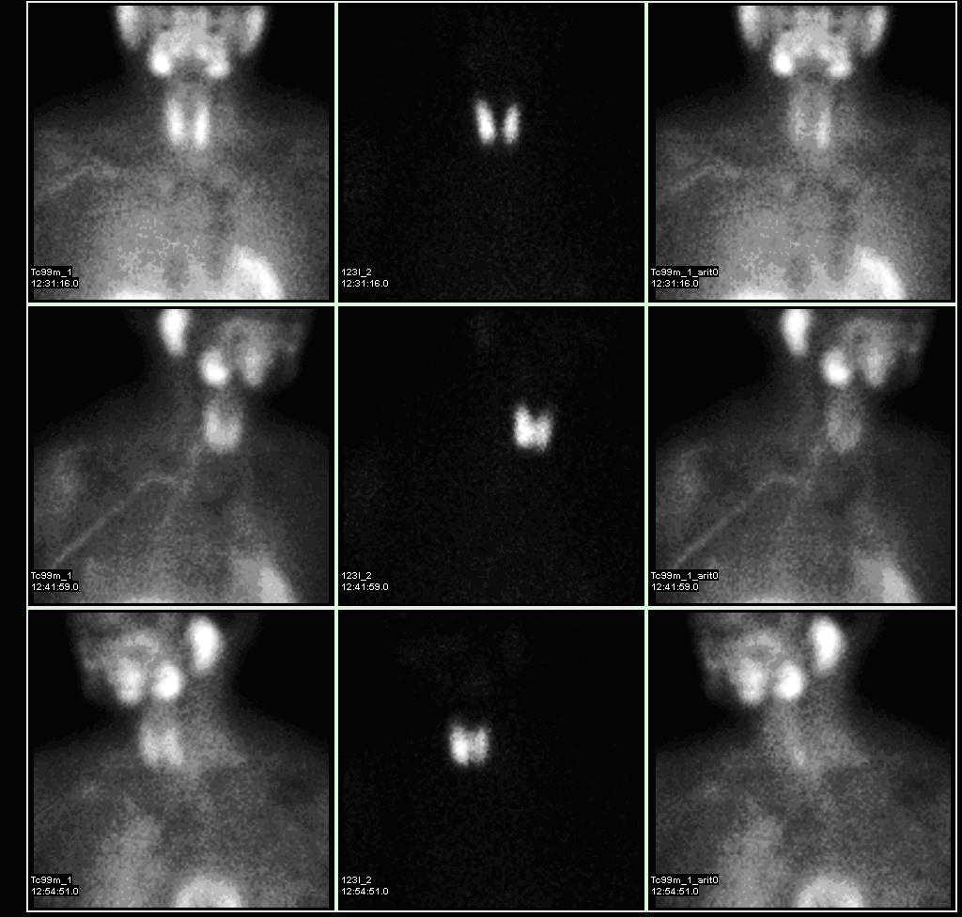Nuclear imaging is a technique that uses radioisotopes to emit radiation from within a patient’s body. A radioisotope is given to a patient either orally, by injection or it can be inhaled. Nuclear imaging can provide doctors with information that other techniques can’t. For example, X-rays can only image bone but nuclear imaging can take pictures of both bone and soft tissue. With nuclear imaging doctors can detect secondary cancer up to two years before it can be seen in a standard X-ray.

The radioisotopes used in nuclear imaging are usually gamma emitters. Doctors use a special gamma camera to detect the gamma radiation and create an image to help diagnose diseases such as cancer. Different elements are used including isotopes of technetium, gallium, iodine, xenon and thallium. The type of radioisotope used depends on which part of the body is being investigated. For example, Iodine-131 is used to take images of the thyroid.

Nuclear imaging can show the position and concentration of the radioisotope in the patient’s body. A ‘hot spot’, an area where the radioisotope has been absorbed into the tissue or organ may be due to a diseased state, such as infection or cancer.

**Iodine Radioisotopes**

Iodine radioisotopes are often used to take images of the thyroid, a gland in your neck. Iodine-131 is not used often due to the danger it can pose to the patients’ health. Other less-damaging radioisotopes such as Iodine-123 are preferred in most situations.

Iodine-131 contributed to the health problems experienced after the Chernobyl nuclear power plant meltdown. It was also spread through the air after the Fukushima nuclear crisis.

|  |  |  |
| --- | --- | --- |
|  | **Iodine-123** | **Iodine-131** |
| **Decays by:** | 100% Gamma | 90% Beta, 10% Gamma |
| **Half-life:** | 13.22 hours | 8.02 days |

**Figure 3:** Nuclear images of a patient’s head and chest. The thyroid (circled in the third image) appears as a ‘hot spot’.

1. State the key difference between nuclear imaging and other imaging techniques. (1 mark)

**Any ONE of the following:**

* Nuclear imaging uses radioisotopes (1)
* Nuclear imaging can image both bone and soft tissue (1)
* Radiation is emitted from within a patient’s body (1)

1. Name two elements used in nuclear imaging. (1 mark)

**Any TWO of the following:**

* Technetium (0.5)
* Gallium (0.5)
* Iodine (0.5)
* Xenon (0.5)
* Thallium (0.5)

1. Explain why nuclear imaging usually uses gamma radiation (instead of alpha or beta radiation). (3 marks)

* Gamma radiation has high penetration (1)
* Therefore, the gamma radiation can escape the body in order to be ‘imaged’/detected (1)
* Gamma radiation is less ionizing than alpha or beta radiation (1)

1. Explain why Iodine-123 is used more often in nuclear imaging than Iodine-131. (3 marks)

* Iodine-131 emits beta radiation, Iodine-123 does not (1)
* Beta radiation has low penetrating power, middle range ionising ability (1)
* Beta radiation could potentially ionise body’s cells on way out, could be damaging (1)

**OR**

* Gamma has high penetrating power, low ionising ability (1)
* Gamma is unlikely to ionise the body’s cells on the way out, not damaging (1)

1. Iodine-131 is created by Tellurium-130 absorbing a neutron, the Tellurium then beta-decays into Iodine-131. Write the nuclear equations for the creation of Iodine-131

(2 marks)

${}_{52}^{130}{Te}+{}_{0}^{1}n→{}_{52}^{131}{Te}$ (1)

${}_{52}^{131}{Te}→{}_{53}^{131}I+{}_{-1}^{0}e$ (1)

1. Draw a graph of ‘fraction of sample remaining’ against ‘time’ for Iodine-123. (4 marks)

|  |  |  |  |  |  |  |  |  |  |  |  |  |  |  |  |  |  |
| --- | --- | --- | --- | --- | --- | --- | --- | --- | --- | --- | --- | --- | --- | --- | --- | --- | --- |
|  |  |  |  |  |  |  |  |  |  |  |  |  |  |  | (1) Scales on axes are correct  (1) Has units on time axes  (1) At least 3 data points graphed (accurately)  (1) Has drawn a line through data points |  |  |
| 1 |  |  |  |  |  |  |  |  |  |  |  |  |  |  |  |  |  |
|  |  |  |  |  |  |  |  |  |  |  |  |  |  |  |  |  |  |
|  |  |  |  |  |  |  |  |  |  |  |  |  |  |  |  |  |  |
| Fraction of sample remaining |  |  |  |  |  |  |  |  |  |  |  |  |  |  |  |  |  |
| 0.5 |  |  |  |  |  |  |  |  |  |  |  |  |  |  |  |  |  |
|  |  |  |  |  |  |  |  |  |  |  |  |  |  |  |  |  |  |
| 0.25 |  |  |  |  |  |  |  |  |  |  |  |  |  |  |  |  |  |
|  |  |  |  |  |  |  |  |  |  |  |  |  |  |  |  |  |  |
|  |  |  |  |  |  |  |  |  |  |  |  |  |  |  |  |  |  |
|  |  |  |  | 13 |  |  | 26 |  | 39 |  |  |  |  |  |  |  |  |
|  |  |  |  |  |  |  | Time (hours) |  |  |  |  |  |  |  |  |  |  |
|  |  |  |  |  |  |  |  |  |  |  |  |  |  |  |  |  |  |

**Question 20 (12 marks)**

**Staying warm in the Arctic**

Inuit people are a collection of indigenous people who live in the Arctic regions of Greenland, Canada and Alaska. In the Arctic the temperature in winter ranges from -35 °C to 0 °C, but it can drop as low as -50 °C. During the summer temperatures range from -10°C up to 10°C.

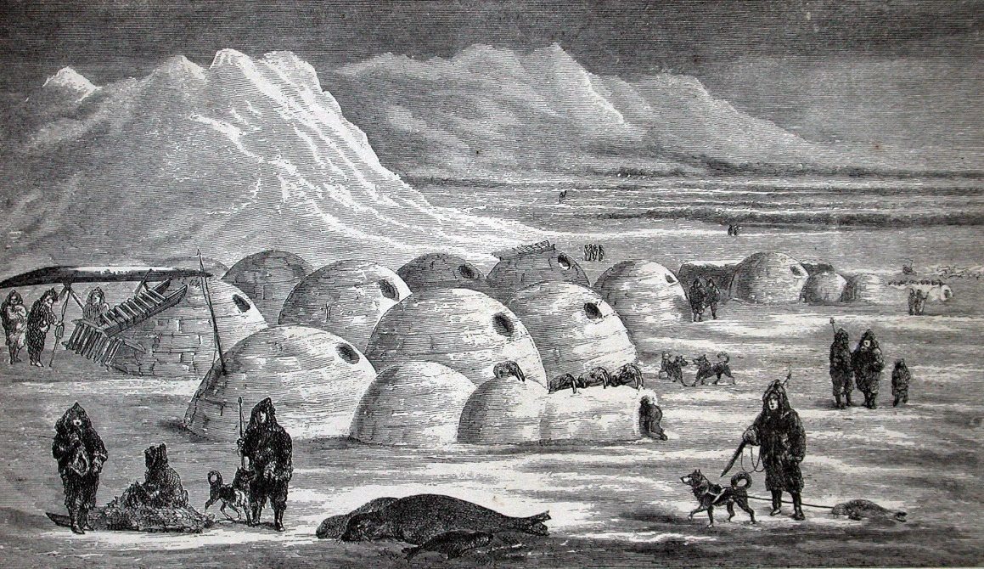

**Figure 4:** Illustration of an Inuit village

On winter hunting trips the Inuit people used to live in temporary shelters called igloos. Igloos are made from compressed snow, which is chopped into large blocks which are then stacked in a dome shape. Compressed snow is used as it contains many small air pockets inside making it a good insulator.

Inside the igloo the floor is uneven with a raised section for sleeping on (see Figure 5). The entrance area acts as a ‘cold trap’ whereas the sleeping area holds any heat generated by stoves, lamps or body heat. Inside the igloo, temperatures can range from −7 °C to 16 °C when warmed by body heat alone. Igloos also have a small ventilation hole to allow smoke from lamps to escape.

Ventilation hole

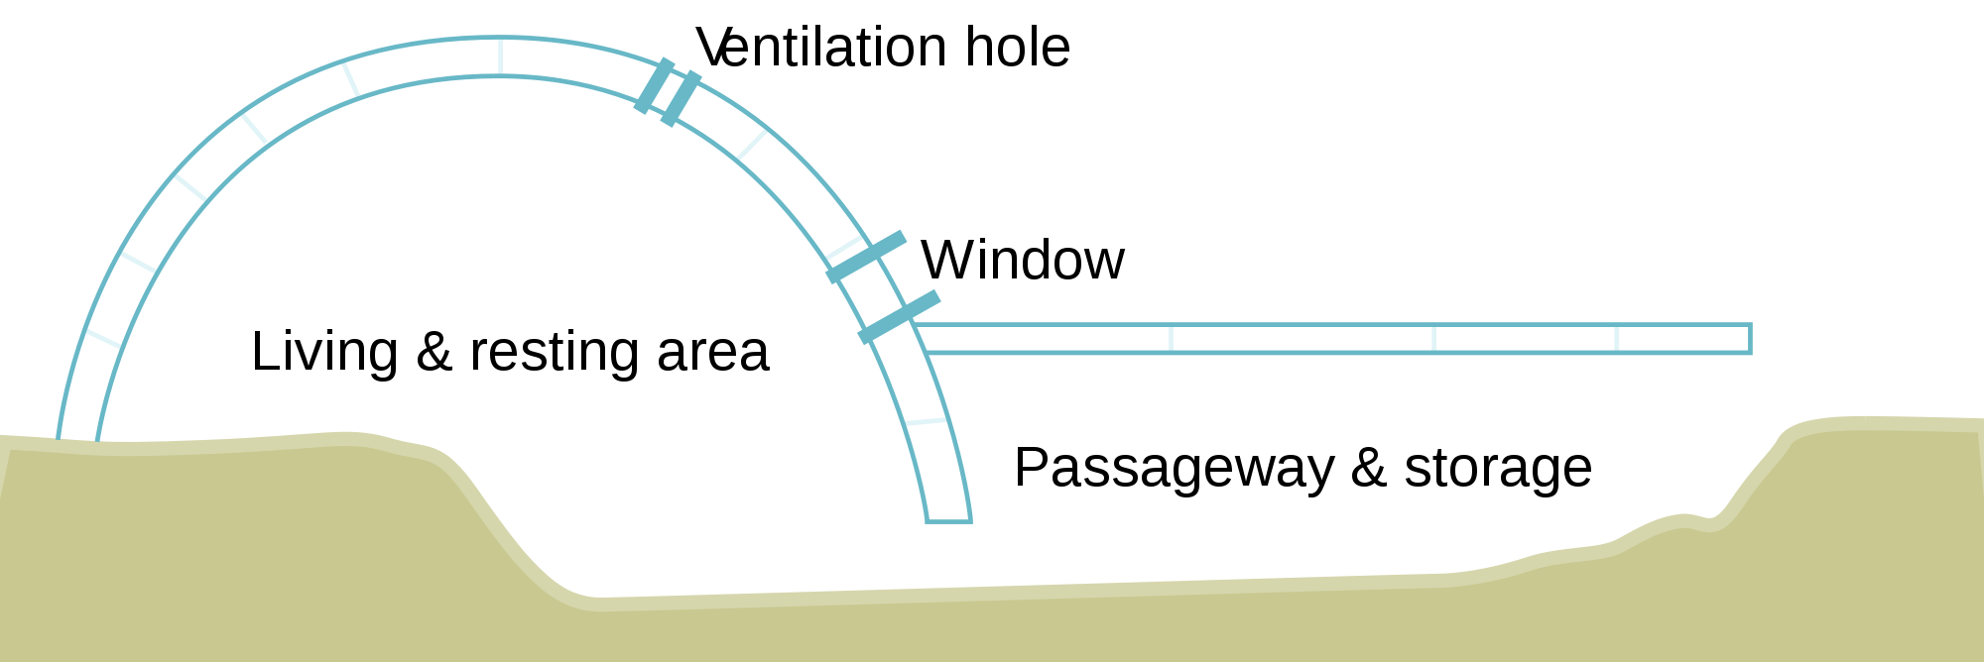

**Figure 5:** Diagram showing the inside of an igloo

1. Explain why the raised sleeping area would ‘hold any heat’ and be warmer than sleeping on the lower level. (3 marks)

* Warm air is less dense than cold air (1)
* Because the warm air is less dense it will rise to the top of the igloo (1)
* This means the raised sleeping area will be warmer than the floor lower down (1)

1. Explain why compressed snow is a better insulator than a solid ice block. (3 marks)

* Compressed snow has small pockets of air – air is a good insulator (1)
* Air is a gas, molecules are further apart than in a solid (1)
* So it takes longer for heat to conduct through air than solid ice (1)

1. Explain why the igloo doesn’t completely melt even when the air temperature inside the igloo is 16 °C. (2 marks)

* Snow/ice has large latent heat of fusion (1)
* The warm air inside the igloo does not have enough energy to melt all of the snow (1)

1. Calculate the amount of energy needed to melt an entire igloo which is at -10 °C. The igloo is made of 150 blocks, each with a volume of 0.05 m3. Compressed snow has a density of $200 kg/m^{3}$. (4 marks)

$$ρ=\frac{m}{V}$$

$0.05\frac{m^{3}}{block}×150 blocks=7.5 m^{3}=V$ (1)

$m=ρ×V$

$m=200×7.5=1500 kg$ (1)

$Q=mc∆T+mL$

$Q=1500×2100×(0--10)+1500×3.34×{10}^{5}$ (1)

$Q=5.33×{10}^{8} J$ (1)

**END OF SECTION THREE**

**Image Credits**

Rainer Knäpper. Fan. CC BY-SA 2.0. Adapted from <https://commons.wikimedia.org/wiki/File:Luefter_y.s.tech_pd1270153b-2f.jpg#mw-jump-to-license>

Augustus Binu. Paper cup. CC BY-SA 4.0. Adapted from <https://commons.wikimedia.org/wiki/File:Paper_cup_DS.jpg>

Rice University. Nuclear reactor diagram. CC BY 4.0. Adapted from <http://cnx.org/contents/Ax2o07Ul@9.39:LJeKXQqg@8/Fission>

Myo Han. Nuclear medicine parathyroid scan. CC BY 3.0. Adapted from <https://en.wikipedia.org/wiki/Sestamibi_parathyroid_scintigraphy#/media/File:Parathyroid_subtraction.jpg>

Igloo. Drawn by unknown artist based on sketches by C.F. Hall and photographed from the book by User:Finetooth - Arctic Researches and Life Among the Esquimaux: Being the Narrative of an Expedition in Search of Sir John Franklin in the Years 1860, 1861, and 1862 by Charles Francis Hall (1865), New York: Harper and Brothers., Public Domain, <https://commons.wikimedia.org/w/index.php?curid=3648025>

Igloo Diagram. By derivative work: Pbroks13 (talk)Igloo_see-through_sideview_diagram.png: - Igloo_see-through_sideview_diagram.png, CC BY-SA 3.0, <https://commons.wikimedia.org/w/index.php?curid=4379835>